Laboratory 12: Exponential Functions for RC circuits
(Edit this document as needed)

Partner 1: Saaif Ahmed

Partner 2: John Gonzalez

Partner 3: _______________________________ (if needed)

Part A
Brief description of RC discharge experiment:
Determine how differently charged capacitors will affect the overall voltage in a circuit, and also determine how changing capacitance values will result in different amounts of decay.

What values of C1 and C2 did you pick? C1: 220 C2: 220

What is the value of R_{discharge} so that the time constant is about 40 seconds? 90.9k Ohms

Oscilloscope plot of discharge voltage of two capacitors for 120 seconds. (Discovery Board)

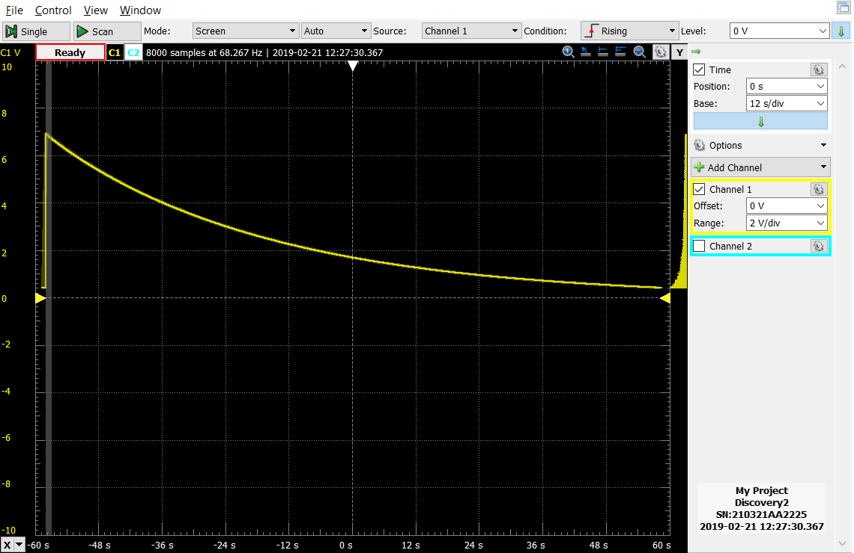

Fill in the table of your measured voltages at times starting from when you disconnected the battery.

Time [s] | Measured Voltage [V] | Calculated Voltage [V]
0 | 6.89 V | 6.89 V
12 | 5.12 V | 5.15 V
24 | 3.83 V | 3.86 V
36 | 2.87 V | 2.89 V
48 | 2.15 V | 2.16 V
60 | 1.62 V | 1.62 V
72 | 1.22 V | 1.21 V
84 | 0.91 V | 0.90 V
96 | 0.68 V | 0.68 V
108 | 0.52 V | 0.51 V
120 | 0.40 V | 0.39 V
Excel plots of Measured Voltage vs. time and Calculated Voltage vs. time, with annotations.

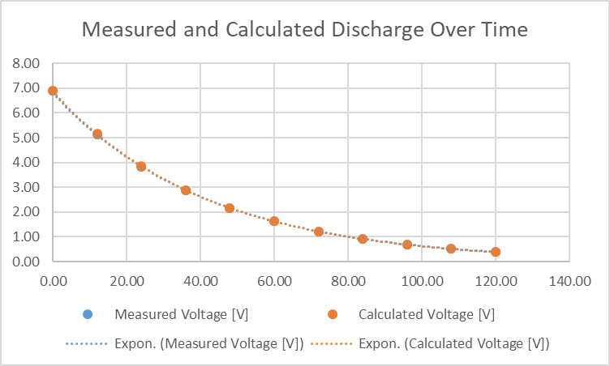

What differences do you observe in the two plots?

They are essentially the same graph. There is very little difference. If anything the measure voltage is a very small percentage lower than the expected voltage.

Equation relating voltage and charge in a capacitor.

Q = C*V

Observations when connecting the discharge capacitor back into the circuit.
When the discharged capacitor is connected back into the circuit, the charge between the capacitors is essentially cut in half reducing the overall voltage in the circuit.

Oscilloscope plot of discharge voltage for 120 seconds when connecting a fully discharged capacitor to the circuit during the discharge time. (Discovery Board)

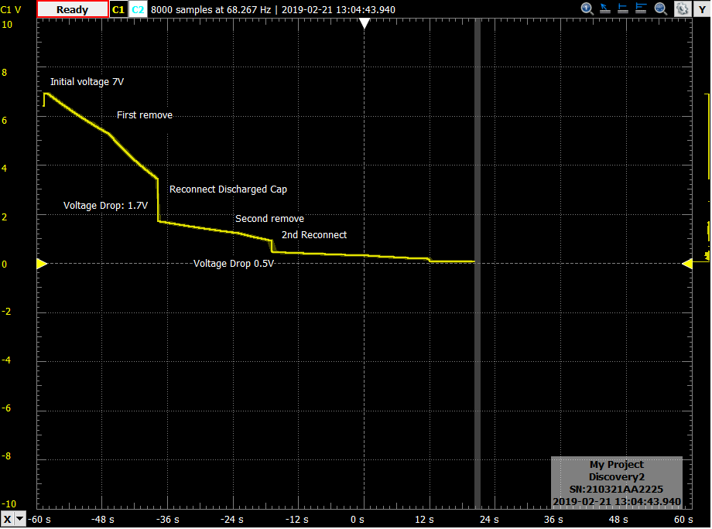

Oscilloscope plot of discharge voltage for 120 seconds when connecting and disconnecting a charged capacitor to and from the circuit during the discharge time. (Discovery Board)

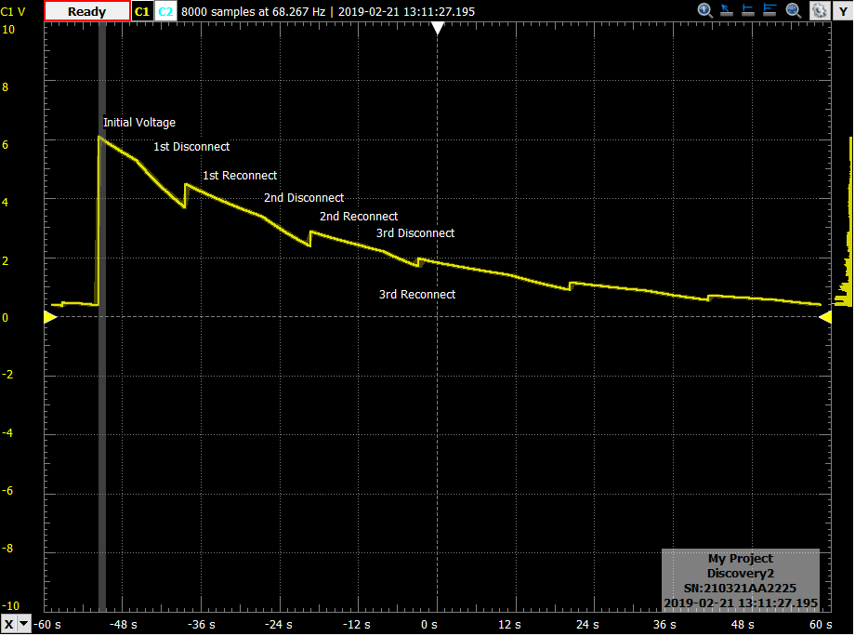

Oscilloscope plot of discharge voltage for 120 seconds when connecting and disconnecting a resistor to and from the circuit during the discharge time. (Discovery Board)

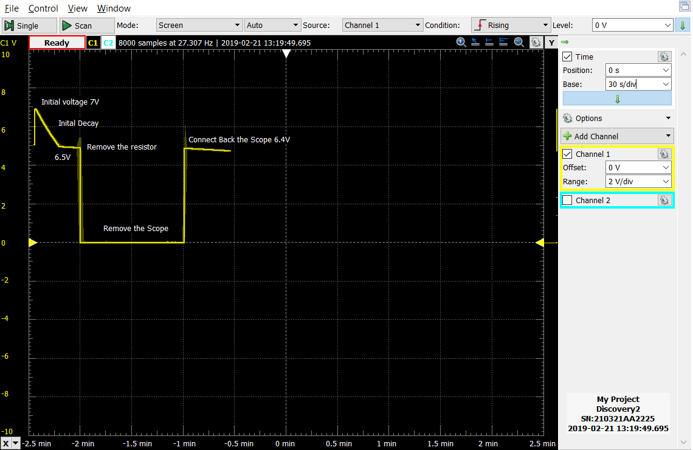

What is the value of R_{discharge} so that the time constant is about 1 millisecond (1μF capacitor)? __________

5k ohms (We used a 4.7k resistor ~ 6% difference)

Oscilloscope plot of discharge voltage for 30-50ms with the new RC circuit. (Discovery Board)

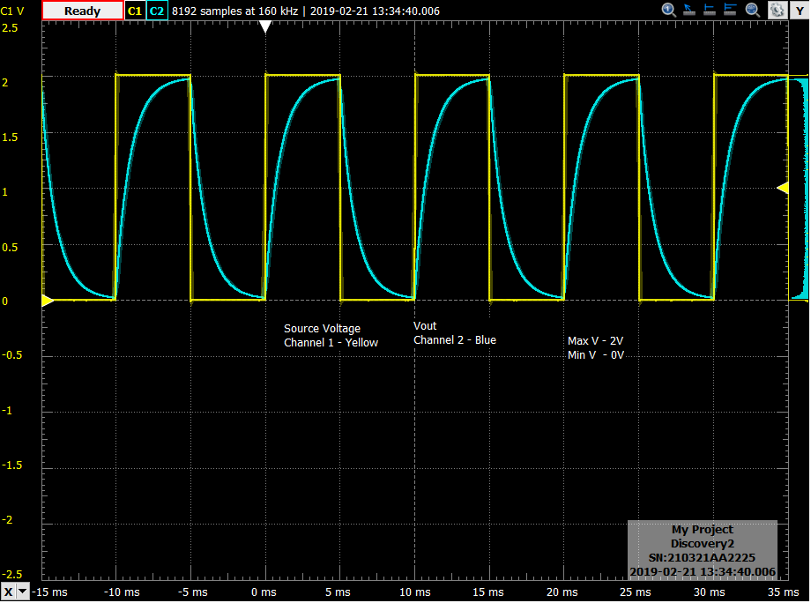

In Excel, using the new RC decay constant and the time column from your saved data file, plot the Calculated Voltage vs. time. On the same plot, provide the Measured Voltage vs. time. Add annotations to your plots.

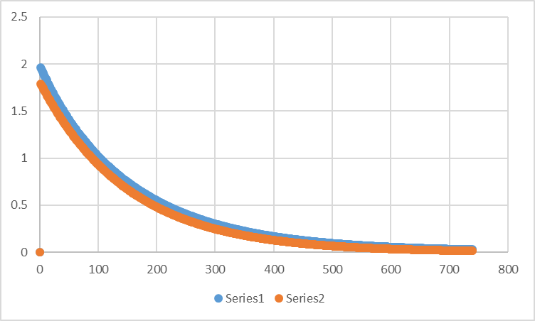

How do the two plots compare?

The plots are very similar and within reasonable error of each other

Part B
Brief description of I-V capacitor experiment:

Analyze the change in current in an RC decay circuit, and determine if the approximation is valuable substitute.

Evaluate the derivative of the exponential function, 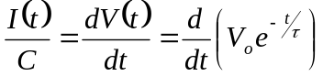, where τ = RC?

I(t)= (C)(-Ve^(-t/RC))/RC

Verification of your calculation by the Teaching Assistant/Instructor. ____YL_________

Oscilloscope plot of discharge voltage and current for the RC circuit. (Discovery Board)

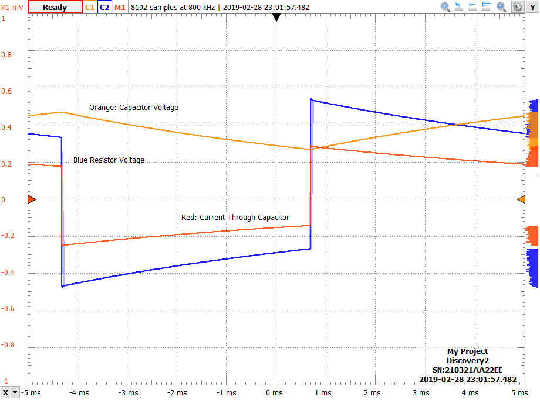
In Excel, using your derived current expression, the RC decay constant and the time column from your saved data file, plot the Calculated Current vs. time. On the same plot, provide the Measured Current vs. time. Add annotations to your plots.

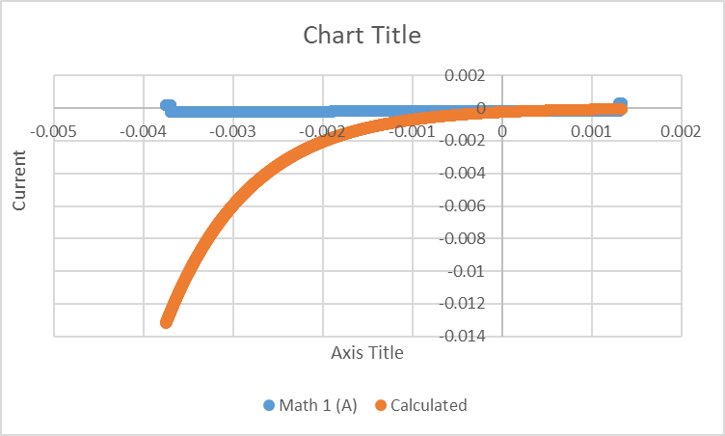
Blue: Measured
Orange: Calculated
In Amps

In Excel, applying the linear approximation given in the lab to your above exponential function, calculate the approximate current. Plot the approximate current along with your previously calculated current and measured current. Add annotations to your plots.

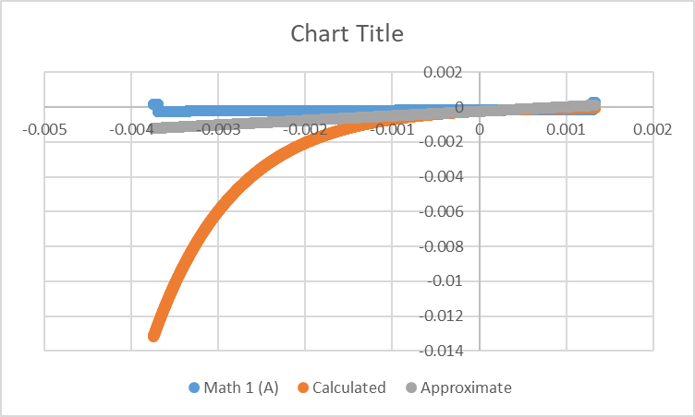
Blue: Measured
Orange: Calculated
Gray: 1+x approximation
In Amps

For what part of the curve is the linear approximation reasonably good?

The approximation is good from about -1ms to about 1ms.

